Date: 25 July 2018

Prospect Property Group

Co-living brand ‘SoCity’ launches with £30m Leeds landmark site
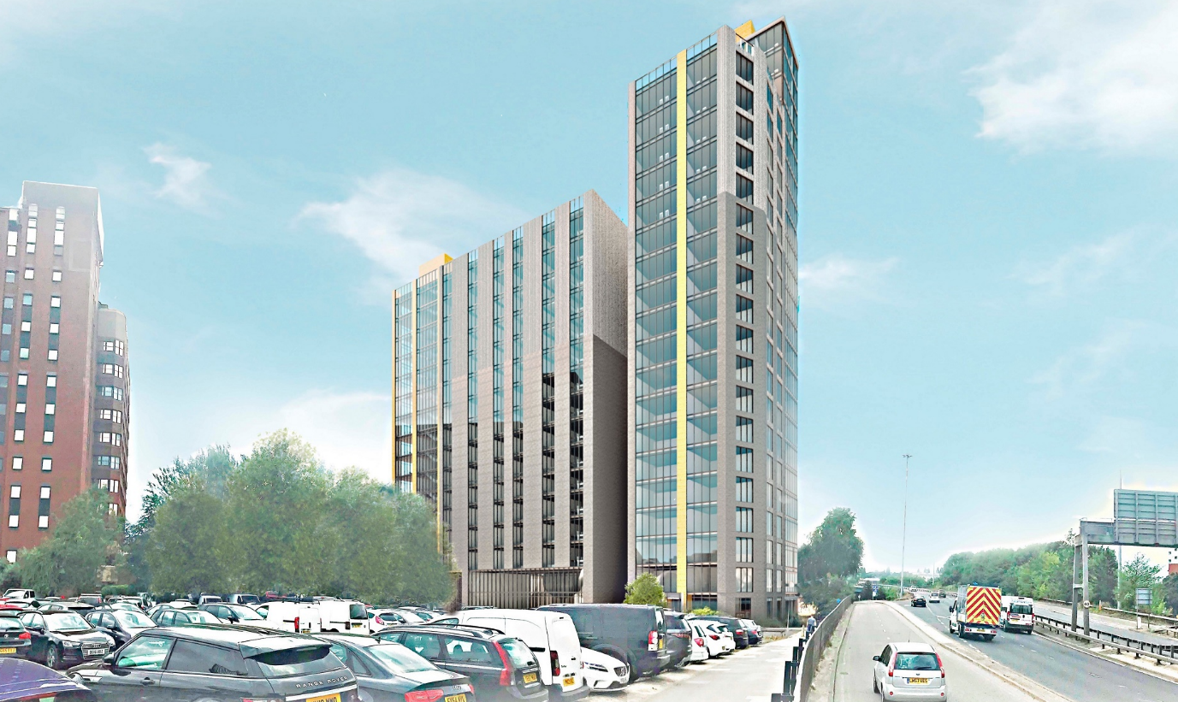

Investors have backed serviced office and property development company Prospect Property Group in the launch of a new national co-living concept – ‘SoCity’.

The ‘SoCity’ brand will provide premium co-living apartments for professionals in city centre locations across the UK, the first site at Lisbon Square in Leeds will see a 23-storey development at a landmark city centre site subject to planning approval this summer.

‘SoCity’ will offer studios, one, two and three bed apartments for young professionals with 24-hour concierge and security, weekly cleaning and linen services, co-working hubs, communal coffee and social areas and state of the art gym and cinema facilities, all designed to bring people together.

Leases on the fully furnished apartments and studios will be for a minimum of 12 months and can be signed individually or as sharers.

Five further planning applications are anticipated this year at sites already negotiated in Wembley, Bristol, Sheffield and Southampton with a total development value of £250m.

Warren Hill, chairman of Prospect Property Group, said; “We are seeing a change in what young professionals want in terms of accommodation when they start their working lives, and co-living will become a significant part of the development mix over coming years. The recognised ‘Prospect’ brand and our 32 year trading experience in the serviced office and shared workspace sector in London have given us the edge over our competitors, and our bespoke IT systems and trained staff made co-living the obvious next step.”

Leeds-based architect Aspect Architecture has been commissioned to design the scheme. James Elliott, partner at Aspect, commented:

“Young people, who can’t or don’t want to own their home want the convenience of a fully equipped, grown up apartment without the up-front cost and time investment that comes with furnishing a home from scratch. They want free superfast WIFI,, turnkey cable TV, and they don’t want the hassle of dealing with all the various utilities.

“They also want all the convenience of in-house services such as laundry and cleaning, and they want to be around people of a similar age and interests. ‘SoCity’ will provide all of this, and we expect that as with similar developments such as ‘The Collective’ in the capital, demand for units will outstrip supply once the concept apartments are launched in 2019.”

SoCity Leeds will see 146 one, two, and three bedroom apartments with a floor designed and dedicated to shared living with coffee bars, event space and co-working hubs available to residence.

The application for the SoCity Leeds development is expected to be decided by planners in September 2018, and work to develop the site could commence as soon as autumn this year.

